`

**2019 IZBC 1/10 Target = $130,000**

**5/12/2019 Nin 1/10 Nung’ae Paw Minccazing**

|  |  |  |
| --- | --- | --- |
| No | Min’ae | Amount |
| 1 | Paaw Maung Maung Inbyn | 60 |
| 2 | Paaw Ko Ko Inbyn | 150 |
| 3 | Paaw Iang Vang Inbyn | 120 |
| 4 | Paaw Peter Thawngzauk Inbyn | 50 |
| 5 | Paaw Pa Hre Inbyn | 122 |
| 6 | Paaw Du Lia Inbyn | 100 |
| 7 | Paaw Le Ting Inbyn | 273 |
| 8 | Paaw Pa Za Ling Inbyn | 235 |
| 9 | Paw Ro Lia Thang | 80 |
| 10 | Paw Thaw Moih | 56 |
| 11 | Paw Ngun Le (Ngain Oo) | 90 |
| 12 | Paaw Aung Win Inbyn | 100 |
| 13 | Paaw Kaw Lei Inbyn | 325 |
| 14 | Paaw Mang Tung Inbyn | 120 |
| 15 | Paaw Thang Tung Mang Inbyn | 60 |
| 16 | Paaw Pa Cing Inbyn | 55 |
| 17 | Paaw Le Za Inbyn | 120 |
| 18 | Paaw Sui Tin Tha Inbyn | 45 |
| 19 |  |  |
|  | **Total** | **2,161** |

LUNGTUANAW TE THAESAKU NAW

1. Atunin A Beih-Inn thyapaw kalang, naethua kho ohpaw zyntu naeblyn tungvawkya Pachia nynh hythuanaw ae la pya vae ohsa. Amen!
2. 2019 Kum lungkhu IZBC Sunday school’ae halang Zyntu blyn nynh Sawsang te tyty vah bung ohsih.
3. Bulletin kya 1/10 Nungpaw thuasa, Lungtuabung nungpaw thuasa, Ccaccanpaw ma thuasa, Nae Min kae pya seipaw umze tuasei leite Kriccaw Piccang’ae kalang naethae sah khonaw Lang oh kae hy oh.
4. Pachia beih-naw inn hynh a thyapaw muin, A thua keiccuze Bawipaw sawtua naw te Mangzia beih thya oh sih.
5. Sawsang nah ngia ry oh paw, Bulletin kya na theih ry oh paw um lang ze nae thae sah kho naw lang oh Bawi Krih minte kae ngia oh.

*Sawsanglangpaw (for prayer requests)*

1. Muisaw zo’ae paw hala, Adaleipaw te Rya’ae lipaw halang,
2. Sia-inn mua hae halang.
3. Ae Buu kya rya latu’ae hala, Sunday School’ae te Ccapah tu’ae hala, Music ounkhua pa hae pawhalang
4. Zotung miakaw hae nynh khumnawba ccin te a lei thung naw lang’ae,
5. Pastor Paaw hae Visa too ku paw te Green Card te Socia hae ah ra te a mue kho naw lang hae.
6. Rya hae hoi la li hae paw halang, rya ah rang te moe ku kho naw lang hae.

**Church Programs**

1. Main Worship service = Sunday 10:00 A.M—12:00 P.M
2. Mino Worship service = Saturday 7:00 P.M—9:00 P.M
3. Woman Worship service = Sunday 7:00 P.M—9:00 P.M
4. Mino Sawsangnaw = Saturday 9:00 P.M—11:00 P.M
5. Nopibuu Sawsangnaw = Saturday 10:00 A.M—12:00 P.M



5-19-2019 Buupi Ccyh ma naw

*Ccyh kyngtu………………Paaw Pa Za Ling*

*Thonaw Sawsa………….Pa Htay*

*Praise&Worship Leader….*

*Peki Honaw…………………*

*Pise Solo……………………Paw Ngain Oo*

*Lungsin Sawsa…………..Paaw Ko Ko*

*Nopi Solo…………………..Noe Mary*

*Zapi Sawsa……………….Nung Ngun Chin*

*Action song………………IZBCY*

*Phung Ho………………….Paaw To Ning*

*Hythuapya……………….Rev. Yan Naung*

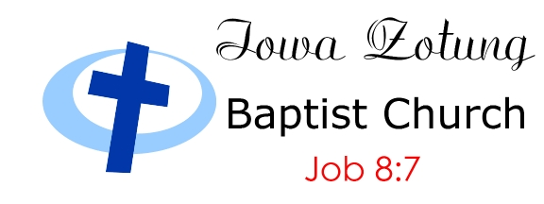

Sunday Bulletin @ 10:00 am to 1:00 pm

May 12, 2019 Des Moines, Iowa

*OUR DEACONS*

*Church Pastor*

*Rev.Yan Naung*

*(515) 776-1189*

**Chairman**

Paaw Le Ting

515-525-5253

***Vice Chairman***

*Paaw Ko Ko*

*515-612-0937*

***Secretar***y

Paaw Peter

804-822-9796

Assit- Secretary

Paaw Pa Hre

***Treasurer***

Paaw Pa Za Ling

813-451-5343

***Join-Treasurer***

Paaw Thang T Mang

515-865-5063

***Music team Lead- Paaw Maung Maung***

***Paw Maung Shwe***

Paw Pa Hre

Paw Kyaw Pi

Paw Ro Lia Tha

Paw Le Zah Tha

Paaw Kyaw T Aung

Mic-ZT Tin Kyaw

**(Computer kyn)**

Noe Mala Cho

Sui Ngun Tial

Van Biak Thang

***(Computer & Bulletins***

Saya Peter Thawngzauk

804-822-9796

*Welcome to Iowa Zotung Baptist Church*

717 E 26nd Street

Des Moines, IA 50317

Email: [izbcusa@gmail.com](mailto:izbcusa@gmail.com)

www.iowazotungbaptistchurch.com

*သင္သည္ အစအဦး၌ငယ္ေသာ္လည္း၊ ေနာက္ဆုံး၌ အလြန္ႀကီးပြားလိမ့္မည္၊၊ ေယာဘဝတၱဳ ၈: ၇*

*Na thonawtuh Adi zema nathang nawkyatuh Myarya na lee cih. Job 8:7*

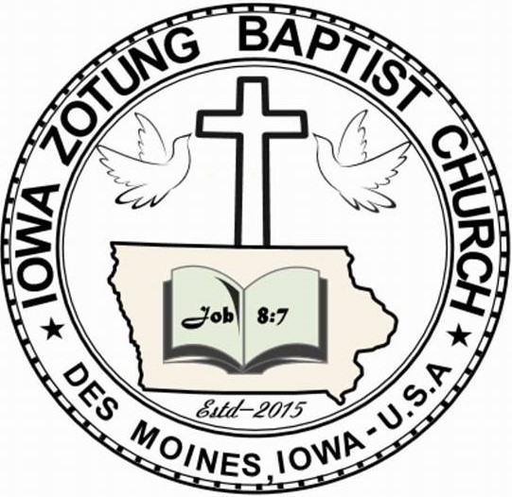

Sunday Bulletin

1/18/2015 Ccyh 1:oopm to 4:00pm

|  |  |  |  |
| --- | --- | --- | --- |
| No. | Title | Ennaw | Mue Vae Paw |
| 1 | 1/10 | $ 130,000 | $59,391.1 |
| 2 | Lungsing/ Lungtua bawm | $ 5,000 | $ 1,399 |
| 3 | Mino Phua | $ 7,000 | $ 200 |
| 4 | Nopibuu Phua | $ 8,000 | $ 700 |
| 5 | CE | $ 800 | $ 300 |
| 6 | Mission | $ |  |

Lunawnnin Pumku Ccyhmanaw - Sunday Service

Merry Christmas

**Happy Mother’s Day**

Ccyhkyngtu (**Chairperson)**……….…......…Nung Phung Tyn

Thonaw sawsa(**Opening prayer**)…………Nung Hnem Te

**Praise & Worship …………………………**

*Peki Honaw- (****Announcements****)……...……*

*Baebuuria……………………………………………….*Nung Shwe Cu Aye

Pise Solo…………………………………..……....Paw Van Bawi Thawng

Ahlu te 1/10 Sawsang…………………………....Paaw Le Tin

Lungsin khoila hae paw …………………………Paaw Iang Vang

Paaw Kyaw Tin Aung

Nung Hae Sawtua pya naw ………………….. Pastor

Solo -------------- Nung Phua Ngun

Nung hae hanglang sawsang------------Paaw Maung Sein

Lunin Hlawsah ……………………………………….Nung Cia Shwe /

Nung Sung Pyn

Action Song …………………………………………..IZBCW

Peki Sawsang (**Special Prayer**)……………Nung Mu Mu

Group Song……………………………………………..IZBCY

Phung Ho (Sermon)…………………………..……Rev. Yan Naung

**Sunday School Children’s…………………**IZBC-SSC

Hythuanaw Hlaw…………………………..…………AMEM AMEN AMEN…

Hythuapya (**Benediction**)……………………...Rev. Yan Naung

**5/19/2019 @ 7:00pm Nopibuu Ccyh**

Ccyh kyngtu ………….…… Nung Shwe Ceu Aye

Thonaw sawsa…………….Paaw Pa Thei Lwin

Praise&Worship Leader…

Peki honaw………………….

Baeburia ……………………Noe Nomi, Paw Caleh

Nopi Solo……………………Nung Hoi Par

Lungsin sawsa…………….Nung Phua Ngun

Pise solo……………………..Paw Thaw Moih

Zapi Sawsa………………….Nung Nu Ki

Phung Ho……………………Nung Cia Shwe

Hythuapya …………………Church Pastor

**5/18/2019 @ 6:00pm Mino Ccyh malang paw**

Ccyhkyntu…………………..Paw Ngain Oo

Thonaw Sawsa……………Noe Su Sa Na

**Praise&Worship Leader… Noe Aye Aye**

Peki honaw…………………

Baeburia…………………….Paw Van Bawi Lia

Pise Solo…………………….Paw Van Biak

Lungsin sawsa…………….Nung Kyi Kyi Ma

Nopi Solo…………………… Noe Susan Par

Zapi Sawsa………………….Paw Kyaw Pi

Innbyn Lawsa…………….Paaw Mathew Kung Innbyn

Phung Ho…………………..Paaw Min Uk Thang

Hythua pya…………….… Pastor